Citizen Pruner Event – Thursday October 12, 2017
Mark Park – 405 11th Ave. S, Princeton
3:00 – 5:00pm

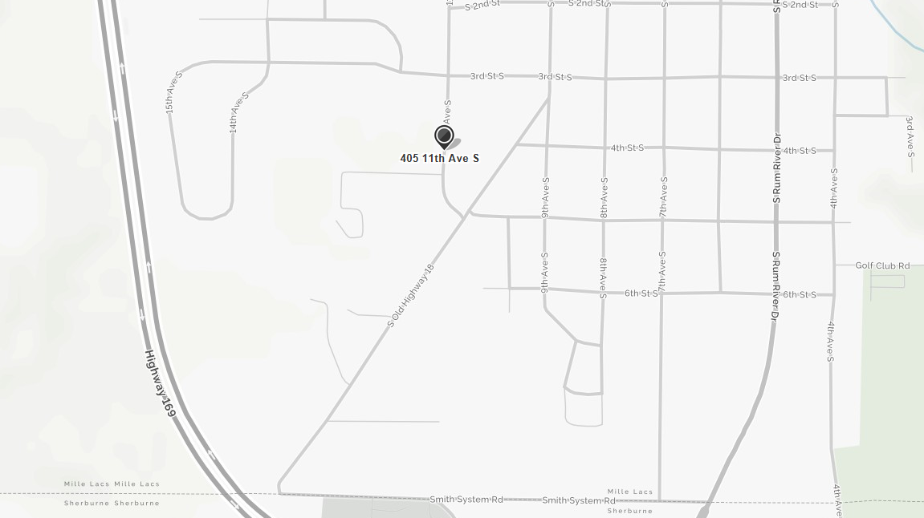
Gina Cell: 763-257-9501 – call or text with questions anytime

