Citizen Pruner Event – Wednesday February 13th, 2019
West Oaks Park - 14375 183rd Ave NW, Elk River
2:00-4:00 p.m.
Franny Cell: 612-708-4496
Call or text with questions

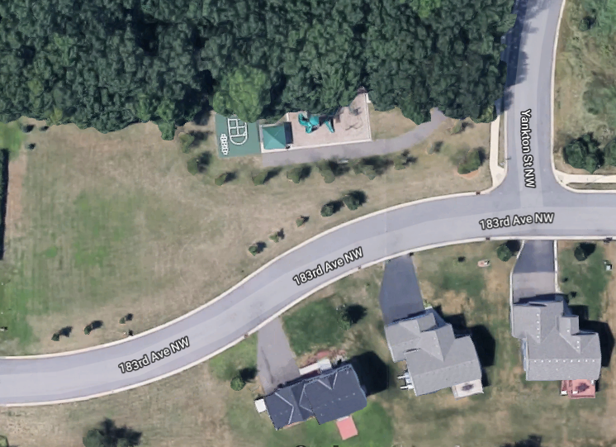
Meet Here

