Citizen Pruner Event – Wednesday February 6th, 2019
Elk River Youth Athletic Complex – 9950 165th Ave NW, Elk River
2:00-4:00 p.m.
Gina Cell: 763-257-9501
Call or text with questions
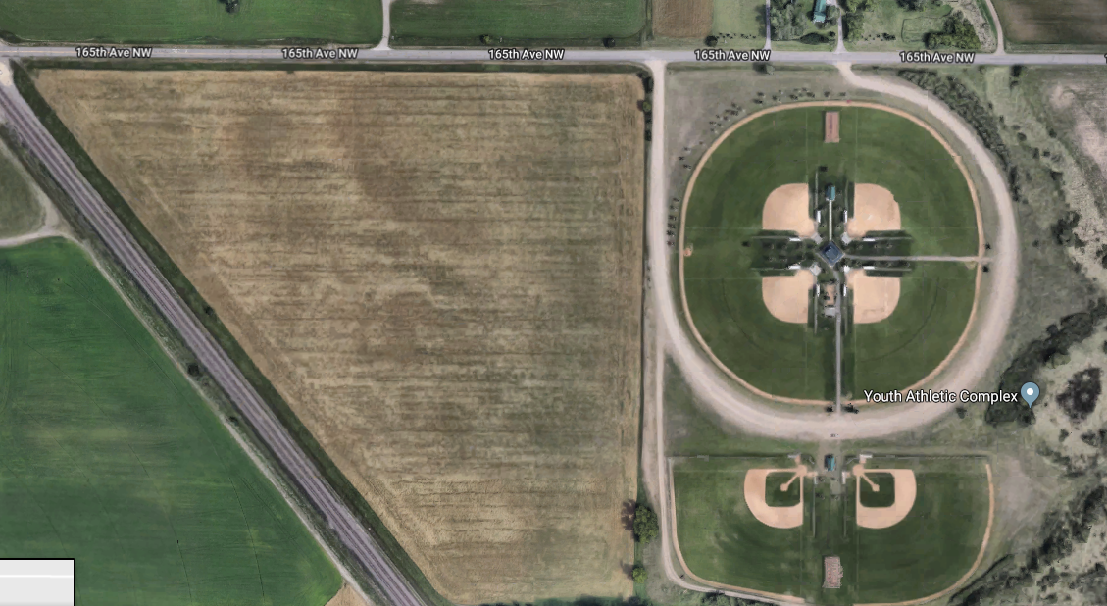
Meet Here

