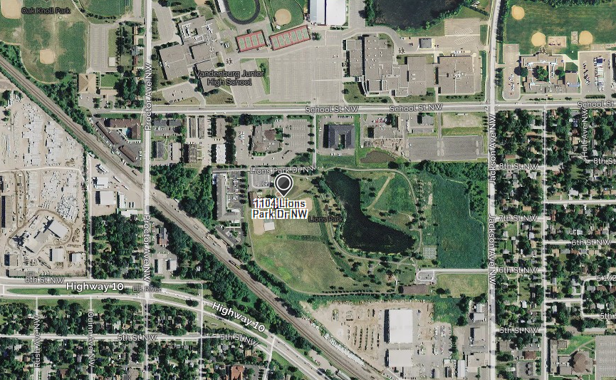

Meet Here

**Citizen Pruner Event – Saturday – March 16, 2019**

**12:30 – 3:00 pm**

**Elk River Lion’s Park**

1104 Lions Park Dr NW, Elk River, MN 55330

Call or text with questions - Franny Cell: 612-708-4496 or Gina Cell: 763-257-9501