Citizen Pruner Event – Tuesday March 12th, 2019
Rainbow Park – Rum River Dr. & 12th St. N, Princeton
2:00-4:00 p.m.
Gina Cell: 763-257-9501 or Franny Cell: 612-708-4496
Call or text with questions
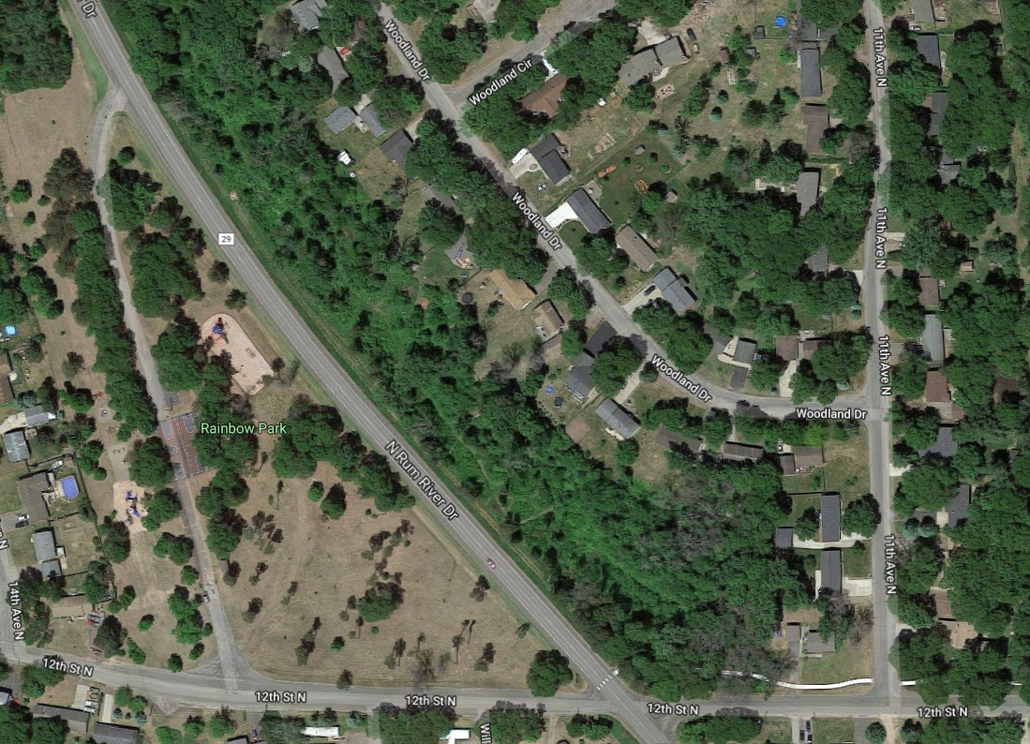
Meet Here

